MPMC MID-3 CONFIDENTIAL QUESTIONS

10 Marks

1. a) Write an ALP in 8051 to add two multi-byte numbers present at address 40H and 60H and store the result at 50H. [8M]

b) Write few differences between 8051 and ARM7. [2M]

5 Marks

1. Write an ALP in 8051 to find the largest number in a given set of 8 numbers starting at address 40H and store the result at 50H.

1. Write a program that continuously get 8-bit data from P0 and sends it to P1 while simultaneously creating a square wave of 200 μs period on pin P2.1. Use timer 0 to create the square wave. Assume that XTAL = 11.0592 MHz.

2 Marks

1. What is the Interrupt Priority sequence for the below?

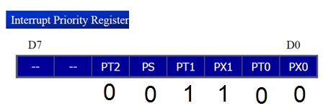

1. What are the different types of read-only memories?
2. Show the instructions to (a) enable the serial interrupt, timer 0 interrupt, and external hardware interrupt 1 (EX1),and (b) disable (mask) the timer 0 interrupt.

1 Mark

1) 8051 supports ____________ serial communication.

2) Write few 8051 family Microcontrollers.

3) Give two examples for Register Indirect Addressing Mode and Register Addressing Mode in 8051.

4) What are the instructions that operate on 16 bit numbers in 8051?